**Class Task Basic**

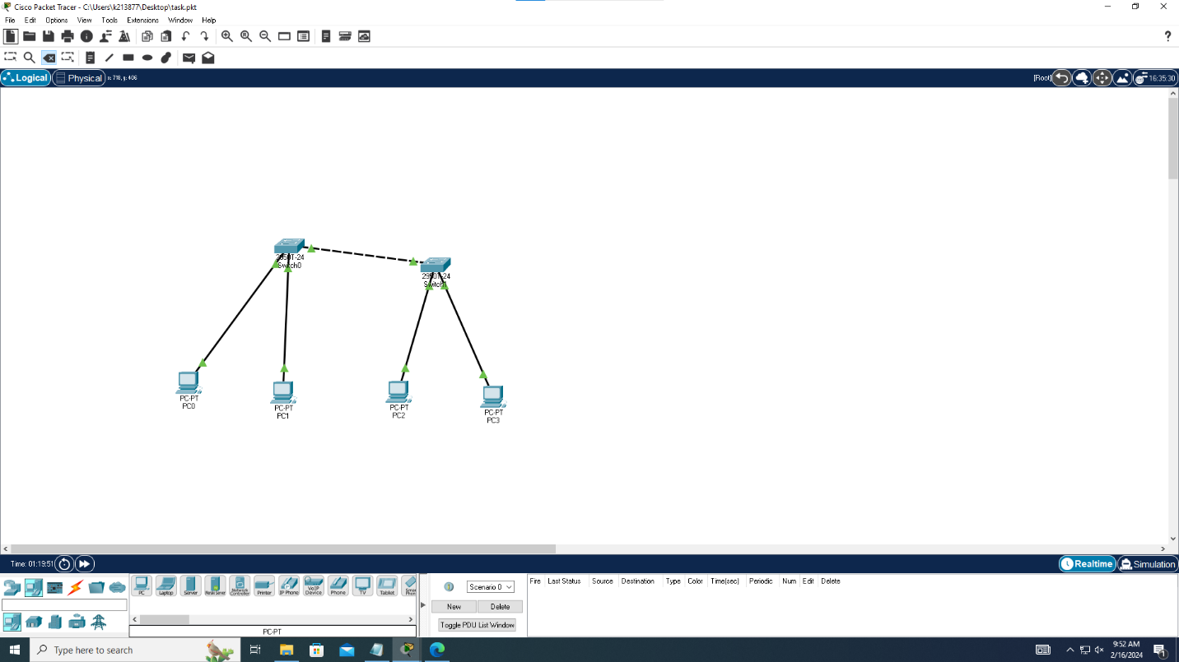

**Lab Task Theoretical:**

**1-ANS)** The difference between the age header and expires is that the age header indicates how long the response has been stored in a cache, while the expires header indicates when the response becomes stale.

The age header is calculated by subtracting the response’s date from the current time. The expires header is set by the server and contains the date/time after which the response is considered stale.

If a response has both the age and expires headers, the cache will use the age header to determine the freshness of the response. If the age is less than the difference between the expires and the date headers, the response is fresh. Otherwise, it is stale.

The age and expires headers are part of the HTTP/1.0 protocol. In HTTP/1.1, the cache-control header with the max-age directive is preferred over the expires header, as it is more accurate and easier to use.

**2-ANS)** HTTP headers can be grouped into four categories:

1. **General Headers**: These headers provide information relevant to both requests and responses but do not directly relate to the data in the message body.
2. **Request Headers**: These headers contain information about the client and the requested resource. They help convey additional details about the resource to be fetched or the client making the request.
3. **Response Headers:** These headers include server-specific details related to the response. They provide information such as the server’s time, location, and configuration.
4. **Representation Headers:** These headers contain information about the body of the resource, including its MIME type or any applied encoding or compression.

**Lab Task Practical (Cisco and connectivity):**

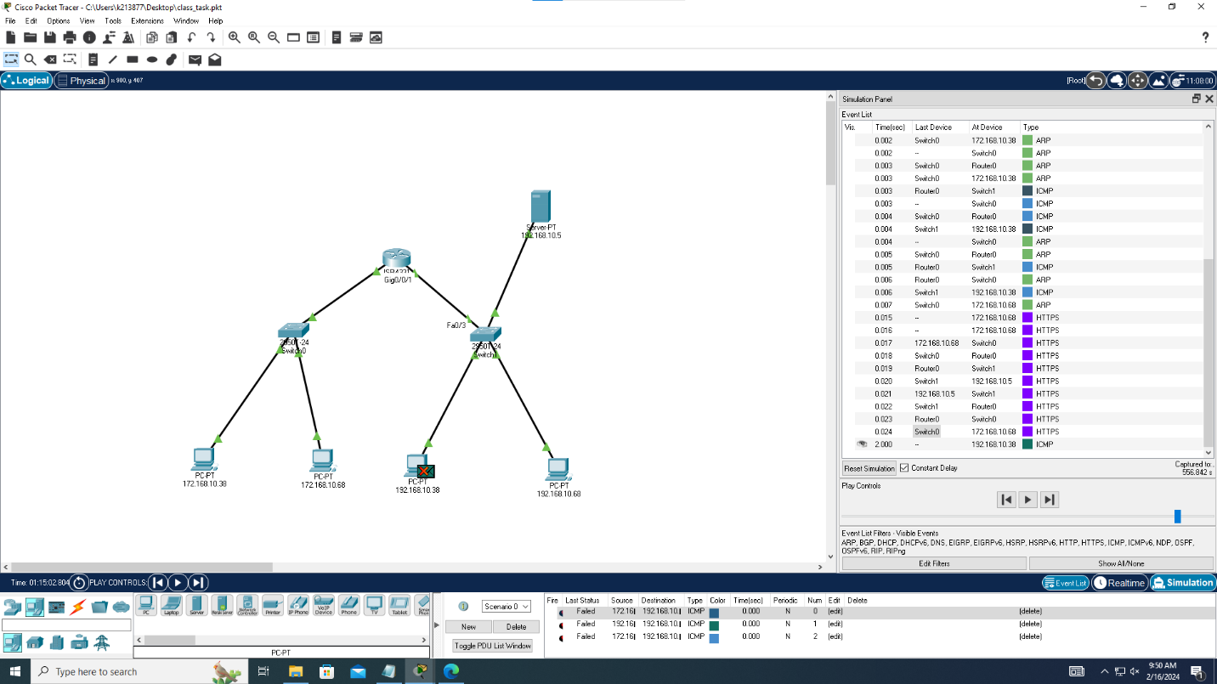



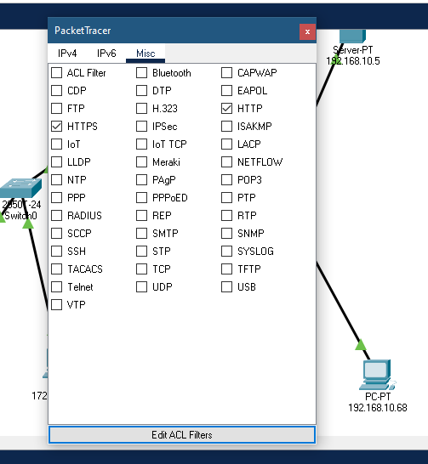

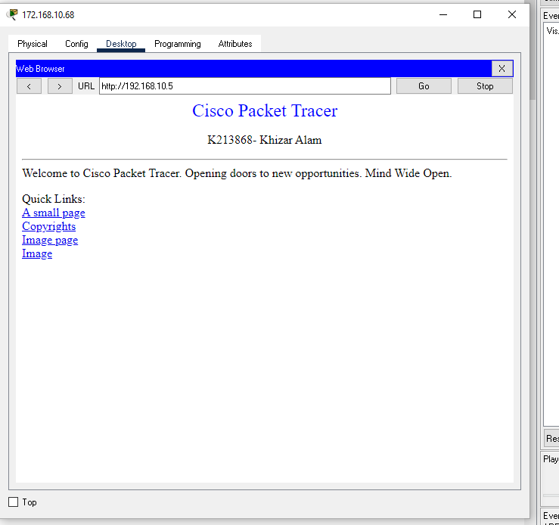



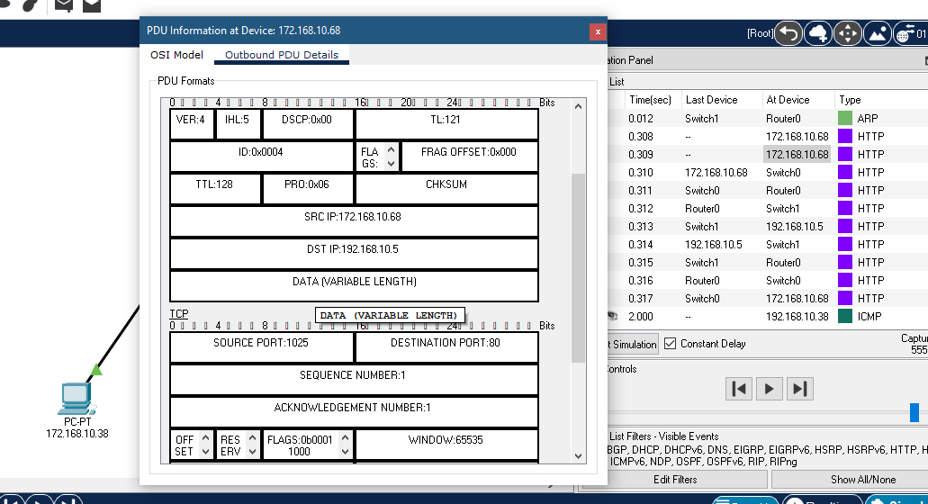



**Wireshark both Http and Https catches:**

Basically HTTPS adds a layer of security by using SSL/TLS protocols to encrypt the data transmitted between the web server and the client, providing a secure and encrypted communication channel (facebook for eg) however as compare to http site that not the case.

